Practical Lab Answers
- A. https://www.javatpoint.com/kali-linux-installation

B. https://www.geeksforgeeks.org/how-to-install-virtual-box-in-kali-linux/

- https://www.geeksforgeeks.org/linux-directory-structure/

- A. https://www.javatpoint.com/linux-commands

B. https://www.redhat.com/sysadmin/introduction-vi-editor

- Theory related to 10 to 12 Networking devices(8 Network device write in 2.3 lecture in class). (If you know about create topology then 1 topology)[Cisco packet Tracer]

- Hello print program:

#include <stdio.h>
#include <unistd.h>
#define MSGSIZE 16
char* msg1 = "hello friends";
char* msg2 = "hello, world #2";
char* msg3 = "hello, world #3";
int main()
{
char inbuf[MSGSIZE];
int p[2], i;
if (pipe(p) < 0)
exit(1);
/* continued */
/* write pipe */
write(p[1], msg1, MSGSIZE);
write(p[1], msg2, MSGSIZE);
write(p[1], msg3, MSGSIZE);
for (i = 0; i < 3; i++) {
/* read pipe */
read(p[0], inbuf, MSGSIZE);
printf("% s\n", inbuf);
}
return 0;
}

- Character count program in string:
#include <stdio.h>
#include <string.h>

int main()
{
char s[1000],c;
int i,count=0;

printf("Enter the string : ");
gets(s);
printf("Enter character to be searched: ");
c=getchar();

for(i=0;s[i];i++)
{
if(s[i]==c)
{
count++;
}
}

printf("character '%c' occurs %d times \n ",c,count);

return 0;
}

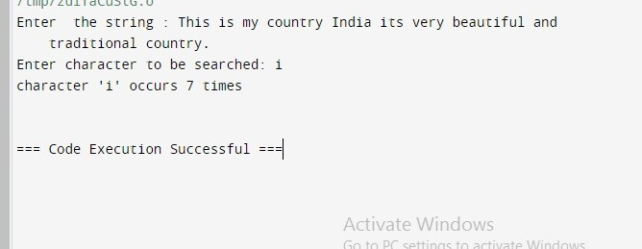
- Bits count program stuff :

#include <stdio.h>
int countSetBits(int n) {
int count = 0;
while (n) {
count += n & 1;
n >>= 1;
}
return count;
}

int main() {
int num;
printf("Enter an integer: ");
scanf("%d", &num);

int result = countSetBits(num);
printf("Number of set bits in %d: %d\n", num, result);

return 0;
}

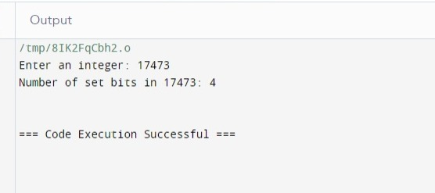
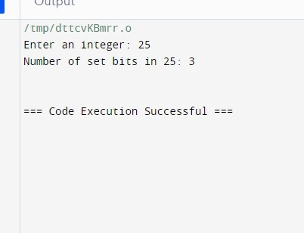

- Perform a GNU C program to generate frames from sender’s message by splitting message by given frame-length.

#include <stdio.h>
#include <string.h>

#define MAX_MESSAGE_LENGTH 1000

void generateFrames(char *message, int frameLength) {
int messageLength = strlen(message);
int numFrames = (messageLength + frameLength - 1) / frameLength; // Calculate the number of frames needed
int i, j;

printf("Frames:\n");
for (i = 0; i < numFrames; i++) {
printf("Frame %d: ", i + 1);
for (j = 0; j < frameLength && (i * frameLength + j) < messageLength; j++) {
printf("%c", message[i * frameLength + j]);
}
printf("\n");
}
}
int main() {
char message[MAX_MESSAGE_LENGTH];
int frameLength;

printf("Enter the message: ");
fgets(message, sizeof(message), stdin);
message[strcspn(message, "\n")] = '\0'; // Remove trailing newline

printf("Enter the frame length: ");
scanf("%d", &frameLength);

generateFrames(message, frameLength);

return 0;
}

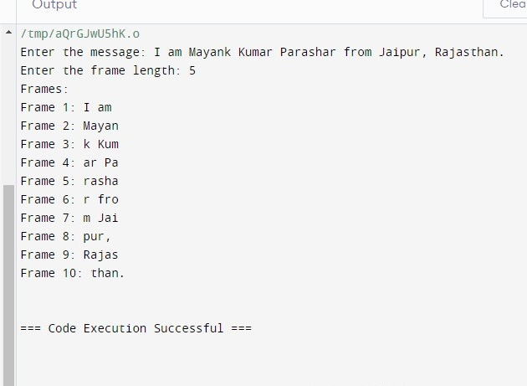

- II) Character Stuffing Program :
#include <stdio.h>
#include <string.h>

#define MAX_FRAME_SIZE 100

void characterStuffing(char* input, char* stuffed, char delimiter) {
int i, j = 0;
stuffed[j++] = delimiter; // Start and end delimiter

for (i = 0; i < strlen(input); i++) {
if (input[i] == delimiter) {
stuffed[j++] = delimiter; // Escape the delimiter
stuffed[j++] = delimiter; // Duplicate the delimiter
} else {
stuffed[j++] = input[i];
}
}

stuffed[j++] = delimiter; // End delimiter
stuffed[j] = '\0'; // Null terminator
}

int main() {
char input[MAX_FRAME_SIZE];
char stuffed[MAX_FRAME_SIZE * 2]; // Maximum possible stuffed frame size
char delimiter;

printf("Enter the frame: ");
fgets(input, sizeof(input), stdin);
input[strcspn(input, "\n")] = 0; // Remove newline character

printf("Enter the delimiter character: ");
delimiter = getchar();
getchar(); // Consume newline character

characterStuffing(input, stuffed, delimiter);

printf("Stuffed frame: %s\n", stuffed);

return 0;
}

- Byte Stuffing :

#include <stdio.h>
#include <string.h>

int main() {
char frame[50][50], str[50][50];
char flag[10];
strcpy(flag, "flag");
char esc[10];
strcpy(esc, "esc");
int i, k = 0, n;
strcpy(frame[k++], flag);
printf("Enter length of String : \n");
scanf("%d", &n);
printf("Enter the String: ");
getchar(); // to clear the buffer
for (i = 0; i < n; i++) {
fgets(str[i], sizeof(str[i]), stdin);
str[i][strcspn(str[i], "\n")] = '\0'; // remove newline character
}
printf("\nYou entered :\n");
for (i = 0; i < n; i++) {
puts(str[i]);
}
printf("\n");
for (i = 0; i < n; i++) {
if (strcmp(str[i], flag) != 0 && strcmp(str[i], esc) != 0) {
strcpy(frame[k++], str[i]);
} else {
strcpy(frame[k++], esc);
strcpy(frame[k++], str[i]);
}
}
strcpy(frame[k++], flag);
printf("------------------------------\n\n");
printf("Byte stuffing at sender side:\n\n");
printf("------------------------------\n\n");
for (i = 0; i < k; i++) {
printf("%s\t", frame[i]);
}
return 0;
}
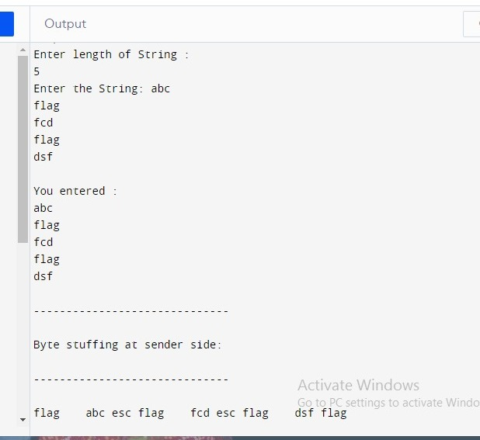

- Bit Stuffing Program:

#include <stdio.h>
#include <string.h>

int main() {
char data[100], stuffedData[200];
int i, count = 0, j = 0;

printf("Enter the data: ");
scanf("%s", data);

for(i = 0; i < strlen(data); i++) {
if(data[i] == '1') {
count++;
stuffedData[j++] = data[i];
} else {
count = 0;
stuffedData[j++] = data[i];
}

if(count == 5) {
count = 0;
stuffedData[j++] = '0';
}
}

stuffedData[j] = '\0';

printf("Data after bit stuffing: %s\n", stuffedData);

return 0;
}

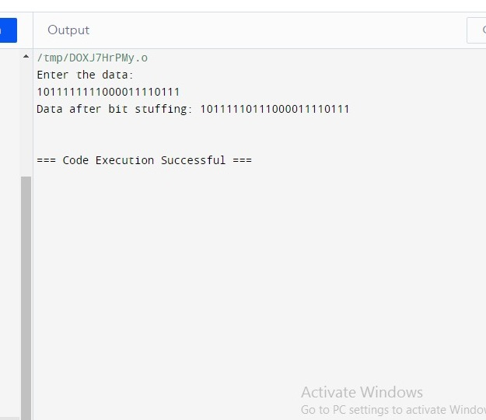

Program 11 LRC :
#include <stdio.h>

// Function to calculate LRC
unsigned char calculateLRC(unsigned char *data, int length) {
unsigned char lrc = 0;
for (int i = 0; i < length; i++) {
lrc += data[i];
}
// Take the one's complement of the sum
lrc = (~lrc) + 1;
return lrc;
}

// Function to print a byte in binary format
void printBinary(unsigned char byte) {
for (int i = 7; i >= 0; i--) {
printf("%d", (byte >> i) & 1);
}
}

int main() {
// Example data to be sent (replace this with your actual data)
unsigned char dataToSend[] = {0x41, 0x42, 0x43, 0x44}; // "ABCD" in ASCII
int dataLength = sizeof(dataToSend) / sizeof(dataToSend[0]);

// Calculate LRC for the data
unsigned char lrc = calculateLRC(dataToSend, dataLength);

// Append LRC to the data
dataToSend[dataLength] = lrc;

// Display the data with appended LRC in binary format
printf("Data with appended LRC (in binary):\n");
for (int i = 0; i < dataLength + 1; i++) {
printBinary(dataToSend[i]);
printf(" ");
}
printf("\n");

return 0;
}

Program 11 Checksum:

#include<stdio.h>
#include<math.h>

int sender(int arr[10],int n)
{
int checksum,sum=0,i;
printf("\n***SENDER SIDE*\n");
for(i=0;i<n;i++)
sum+=arr[i];
printf("SUM IS: %d",sum);
checksum=~sum; //1's complement of sum
printf("\nCHECKSUM IS:%d",checksum);
return checksum;
}
void receiver(int arr[10],int n,int sch)
{
int checksum,sum=0,i;
printf("\n\n***RECEIVER SIDE*\n");
for(i=0;i<n;i++)
sum+=arr[i];
printf("SUM IS:%d",sum);
sum=sum+sch;
checksum=~sum; //1's complement of sum
printf("\nCHECKSUM IS:%d",checksum);
}

void main()
{
int n,sch,rch;
printf("\nENTER SIZE OF THE STRING:");
scanf("%d",&n);
int arr[n];
printf("ENTER THE ELEMENTS OF THE ARRAY TO CALCULATE CHECKSUM:\n");
for(int i=0;i<n;i++)
{
scanf("%d",&arr[i]);
}
sch=sender(arr,n);
receiver(arr,n,sch);
}

Output:
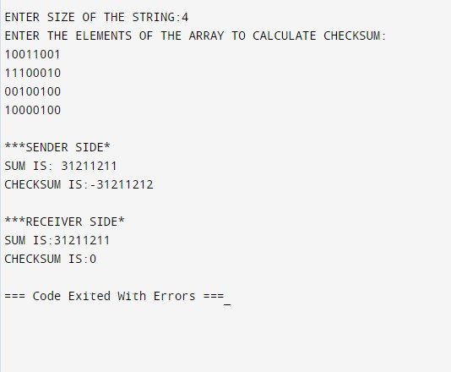

Program 12 CRC:

#include<stdio.h>
#include<string.h>
// length of the generator polynomial
#define N strlen(gen_poly)
// data to be transmitted and received
char data[28];
// CRC value
char check_value[28];
// generator polynomial
char gen_poly[10];
// variables
int data_length,i,j;
// function that performs XOR operation
void XOR(){
// if both bits are the same, the output is 0
// if the bits are different the output is 1
for(j = 1;j < N; j++)
check_value[j] = (( check_value[j] == gen_poly[j])?'0':'1');

}
// Function to check for errors on the receiver side
void receiver(){
// get the received data
printf("Enter the received data: ");
scanf("%s", data);
printf("\n-----------------------------\n");
printf("Data received: %s", data);
// Cyclic Redundancy Check
crc();
// Check if the remainder is zero to find the error
for(i=0;(i<N-1) && (check_value[i]!='1');i++);
if(i<N-1)
printf("\nError detected\n\n");
else
printf("\nNo error detected\n\n");
}

void crc(){
// initializing check_value
for(i=0;i<N;i++)
check_value[i]=data[i];
do{
// check if the first bit is 1 and calls XOR function
if(check_value[0]=='1')
XOR();
// Move the bits by 1 position for the next computation
for(j=0;j<N-1;j++)
check_value[j]=check_value[j+1];
// appending a bit from data
check_value[j]=data[i++];
}while(i<=data_length+N-1);
// loop until the data ends
}

int main()
{
// get the data to be transmitted
printf("\nEnter data to be transmitted: ");
scanf("%s",data);
printf("\n Enter the Generating polynomial: ");
// get the generator polynomial
scanf("%s",gen_poly);
// find the length of data
data_length=strlen(data);
// appending n-1 zeros to the data
for(i=data_length;i<data_length+N-1;i++)
data[i]='0';
printf("\n----------------------------------------");
// print the data with padded zeros
printf("\n Data padded with n-1 zeros : %s",data);
printf("\n----------------------------------------");
// Cyclic Redundancy Check
crc();
// print the computed check value
printf("\nCRC or Check value is : %s",check_value);
// Append data with check_value(CRC)
for(i=data_length;i<data_length+N-1;i++)
data[i]=check_value[i-data_length];
printf("\n----------------------------------------");
// printing the final data to be sent
printf("\n Final data to be sent : %s",data);
printf("\n----------------------------------------\n");
// Calling the receiver function to check errors
receiver();
return 0;
}

Output:

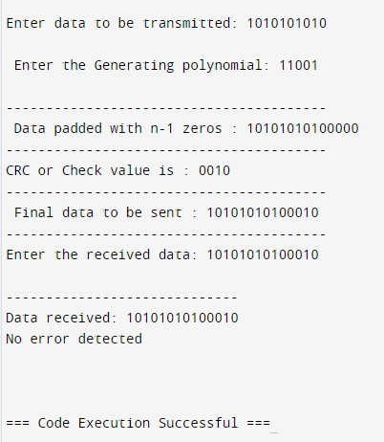

Practical No. 13 Hamming Code :

#include <stdio.h>
#include <math.h>
int input[32];
int code[32];
int ham_calc(int,int);
void main()
{
int n,i,p_n = 0,c_l,j,k;
printf("Please enter the length of the Data Word: ");
scanf("%d",&n);
printf("Please enter the Data Word:\n");
for(i=0;i<n;i++)
{
scanf("%d",&input[i]);
}

i=0;
while(n>(int)pow(2,i)-(i+1))
{
p_n++;
i++;
}

c_l = p_n + n;

j=k=0;
for(i=0;i<c_l;i++)
{

if(i==((int)pow(2,k)-1))
{
code[i]=0;
k++;
}
else
{
code[i]=input[j];
j++;
}
}
for(i=0;i<p_n;i++)
{
int position = (int)pow(2,i);
int value = ham_calc(position,c_l);
code[position-1]=value;
}
printf("\nThe calculated Code Word is: ");
for(i=0;i<c_l;i++)
printf("%d",code[i]);
printf("\n");
printf("Please enter the received Code Word:\n");
for(i=0;i<c_l;i++)
scanf("%d",&code[i]);

int error_pos = 0;
for(i=0;i<p_n;i++)
{
int position = (int)pow(2,i);
int value = ham_calc(position,c_l);
if(value != 0)
error_pos+=position;
}
if(error_pos == 1)
printf("The received Code Word is correct.\n");
else
printf("Error at bit position: %d\n",error_pos);
}
int ham_calc(int position,int c_l)
{
int count=0,i,j;
i=position-1;
while(i<c_l)
{
for(j=i;j<i+position;j++)
{
if(code[j] == 1)
count++;
}
i=i+2*position;
}
if(count%2 == 0)
return 0;
else
return 1;
}

OUTPUT :

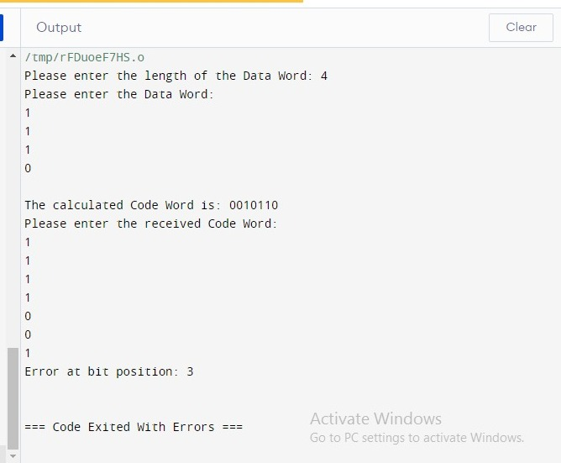

Program 14 Leaky Bucket :

#include <stdio.h>
#include <stdlib.h>
#include <unistd.h> // For sleep function

int main() {
int i, packets[10], content = 0, newcontent, time, clk, bucket_size, output_rate;

// Generate random packet sizes
for (i = 0; i < 5; i++) {
packets[i] = rand() % 10;
if (packets[i] == 0)
i--; // Regenerate if packet size is 0
}

printf("\nEnter output rate of the bucket: ");
scanf("%d", &output_rate);

printf("\nEnter Bucket size: ");
scanf("%d", &bucket_size);

for (i = 0; i < 5; ++i) {
if ((packets[i] + content) > bucket_size) {
if (packets[i] > bucket_size)
printf("\nIncoming packet size %d greater than the size of the bucket\n", packets[i]);
else
printf("\nBucket size exceeded\n");
} else {
newcontent = packets[i];
content += newcontent;
printf("\nIncoming Packet: %d\n", newcontent);
printf("Transmission left: %d\n", content);
time = rand() % 10;
printf("Next packet will come at: %d\n", time);

for (clk = 0; clk < time && content > 0; ++clk) {
printf("\nLeft time: %d", (time - clk));
sleep(1);

if (content > 0) {
printf("\nTransmitted\n");
if (content < output_rate)
content = 0;
else
content -= output_rate;
printf("Bytes remaining: %d\n", content);
} else {
printf("\nNo packets to send\n");
}
}
}
}

return 0;
}

Output :

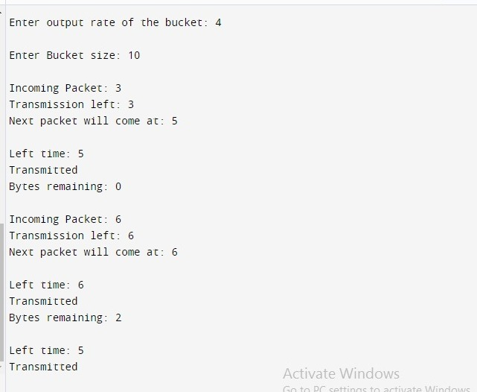
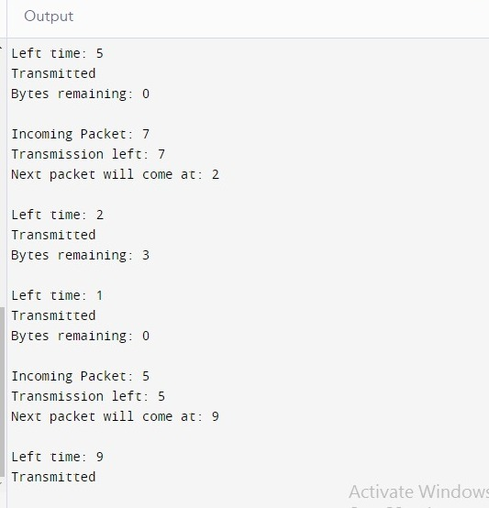
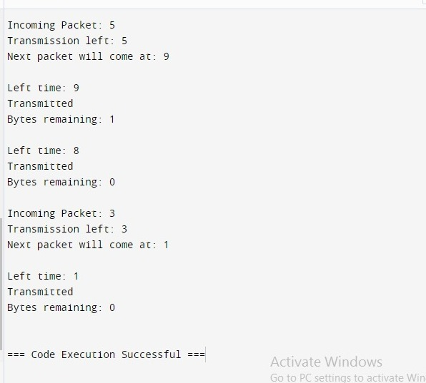

Program 15 Token Bucket :

#include <stdio.h>
#include <stdbool.h>
#include <unistd.h> // for usleep function

int main() {
int bucket_size, output_rate;

// User input for bucket size and output rate
printf("Enter the bucket size: ");
scanf("%d", &bucket_size);
printf("Enter the output rate of the bucket: ");
scanf("%d", &output_rate);

int bucket = 0; // Current size of the bucket

while (true) {
// Generate some data, e.g., incoming packets
int incoming_packets;
printf("Enter the number of incoming packets: ");
scanf("%d", &incoming_packets);

// Add incoming packets to the bucket
if (bucket + incoming_packets <= bucket_size) {
bucket += incoming_packets;
} else {
printf("Bucket overflow! Dropping %d packets.\n", incoming_packets + bucket - bucket_size);
bucket = bucket_size; // Bucket is full
}

// Transmit data from the bucket
if (bucket >= output_rate) {
printf("%d packets transmitted.\n", output_rate);
bucket -= output_rate;
} else {
printf("Bucket empty.\n");
}

// Wait for a second before the next iteration
usleep(1000000); // Sleep for 1 second (1 million microseconds)
}

return 0;
}

Output :

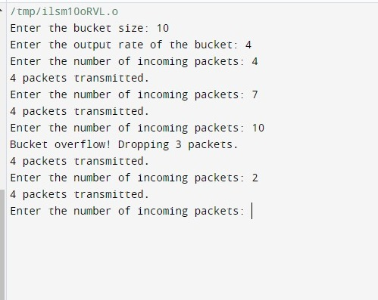

Program : VRC

#include <stdio.h>

int main() {
int data[10], vrc = 0;

// Input data
printf("Enter 7 bits of data: ");
for(int i = 0; i < 7; i++) {
scanf("%d", &data[i]);
}

// Calculate VRC
for(int i = 0; i < 7; i++) {
vrc ^= data[i];
}

// Display VRC
printf("VRC bit is: %d\n", vrc);

return 0;
}

Output :

